Irfan Ahmed
ICP 7
Due Date: 10/12/2020
My explanation
The n_cluster variable value was changed six times to observe how it was affecting the overall clustering groups. From the table below we can see that the number of clusters changes with the change of n_cluster variable value. Some of the cluster groups increased or decreased depending on the closet center, which is the basic concept of K-means, which is partitioning k cluster means to represent k cluster and assigning objects to the closet center, where k is given(class PowerPoint definition). There are some limitations since the algorithm is highly sensitive to outliers for objects with extremely high value and therefore distort the distribution of the data. For n_cluster = 5, 6, and 7, one thing is noticeable right away, that is cluster 4 decreases then increases for n_cluster 7. This could be due to the centroid position and the distance calculated for each data point. Overall, based on n_cluster = 10 the group seems to proportional to each other based on the centroid position.

For n_cluster = 5 group 4 decreases but increased for n_cluster (7).
N_cluster = 5  4 298  2 289  3 245  1 241  0 177 | N_cluster = 6  0 291  5 213  2 213  1 206  4 172  3 155
N_cluster = 7  4 231  5 223  0 187  3 184  1 158  2 137  6 130 | N_cluster = 8  5 229  7 201  1 167  0 152  2 150  3 123  4 120  6 108
N_cluster = 9  3 214  1 185  2 144  7 124  8 123  0 122  5 119  6 114  4 105 | N_cluster = 10  2 188  3 164  9 163  0 162  1 129  4 122  6 107  5 87  7 73  8 55
  - What you learned in the ICP
One of the main components I learned from this ICP was that K – Means clustering can be useful for features where the labels are unknown. This can be useful in finding structure in the unlabeled data. Also, discover groups, and pattern of objects, and can be useful for explorative analysis. Lastly, how the algorithm is implemented. First the parameters are initialized to some random values(theta). Then, the probability is computed for each of the value z, given theta. Next, the computed values of z are computed again to obtain a better estimate for the parameter’s theta. The last two steps are repeated until convergence.
  - ICP description what was the task you were performing.
- First imported the required libraries and creating dataset using make_blobs.
- Standardizing the data by passing in my variable called ‘data’.
- Data was then scaled.
- Created k-means object with initialization as ‘k-means++’
- Then, fitting the k means algorithm on scaled data.
- Used kmeans.inertia_ on the fitted data.
- Used kmean.n_iter_ to find the number of iterations needed to converge.
- Finally, fitting the multiple k – means algorithm and sotring the values in an empty list.
- Used elbow curve method to determine the n_cluster number. For this case I decided to use KneeLocator to find the elbow
- Using kmeans for cluster ranging from 5 – 10, and plotted the results.
  - Challenges that you faced
One of the challenges I faced during this ICP was how to construct a scatter plot and generate my own data. But I was able to figure that out. The most difficult part was making sense of my scatter plots and giving a logical explanation why some clusters increased or decreased.

  - Screen shots that shows the successful execution of each required step of your code
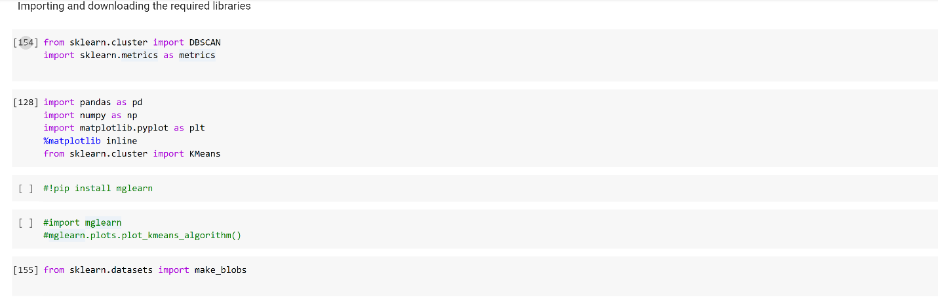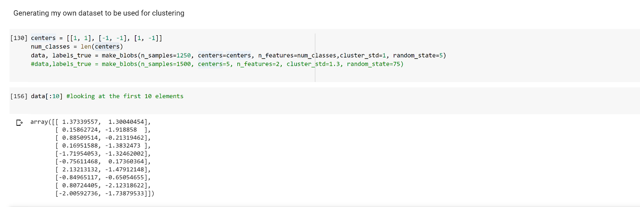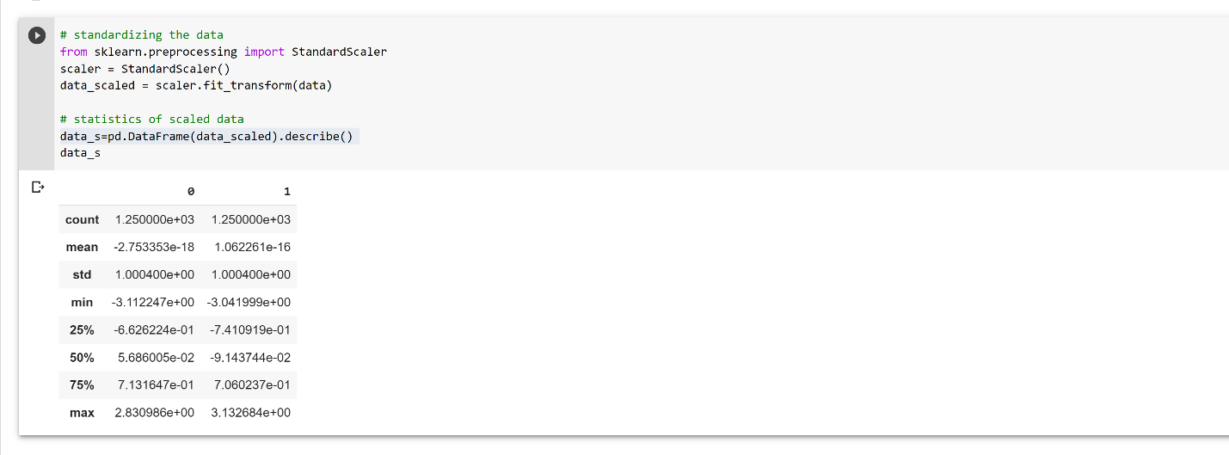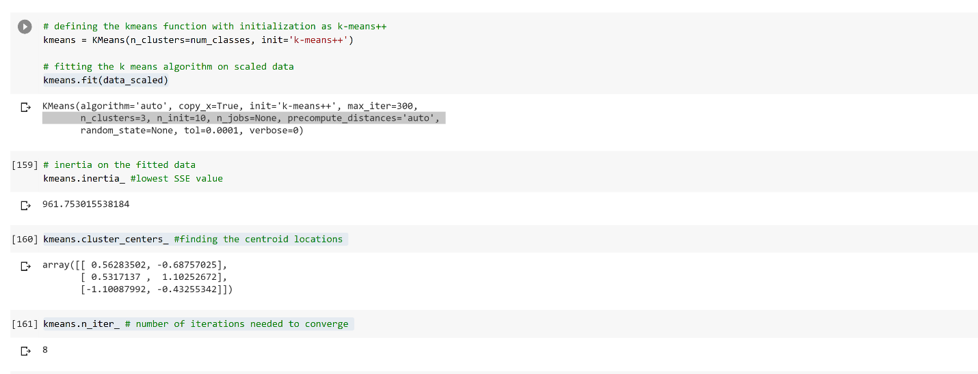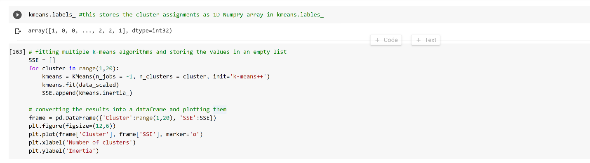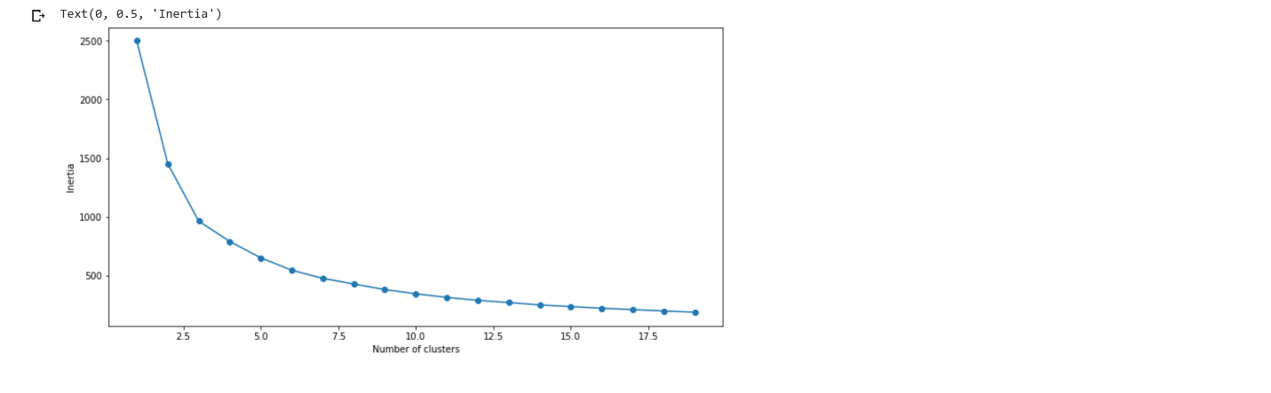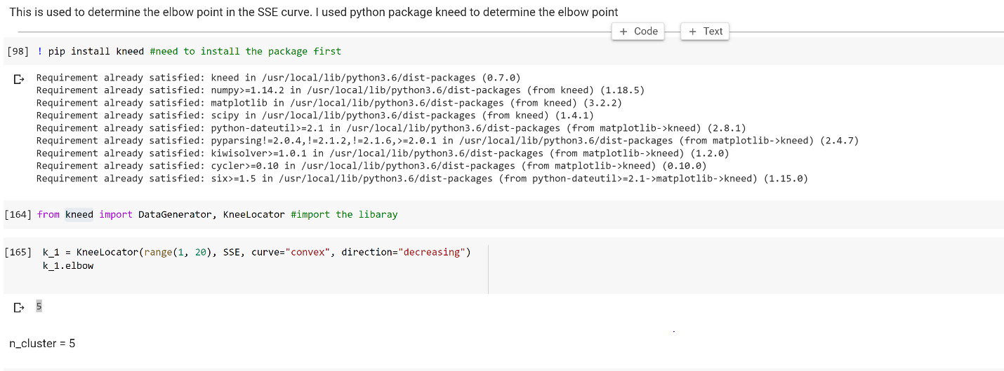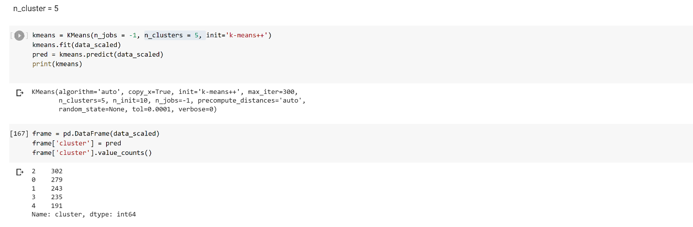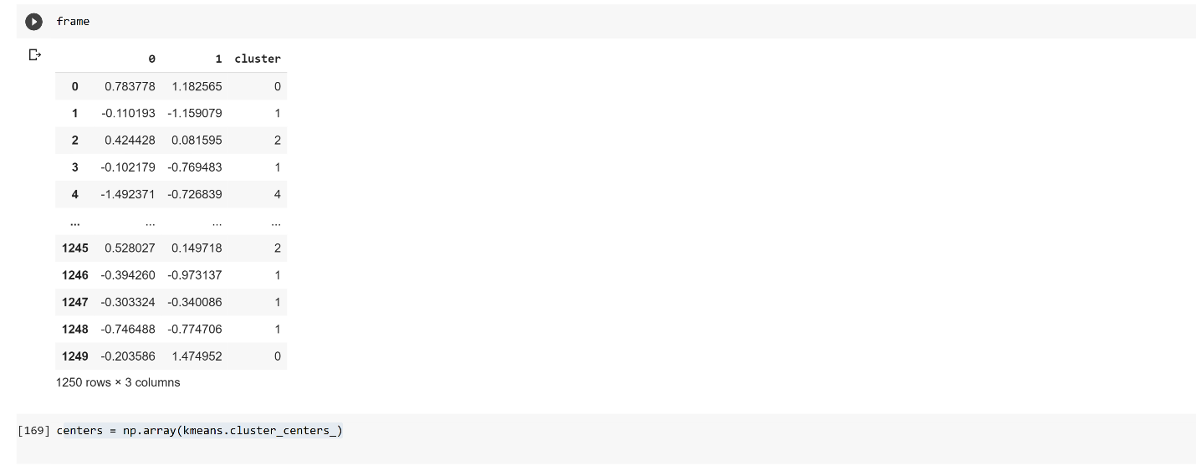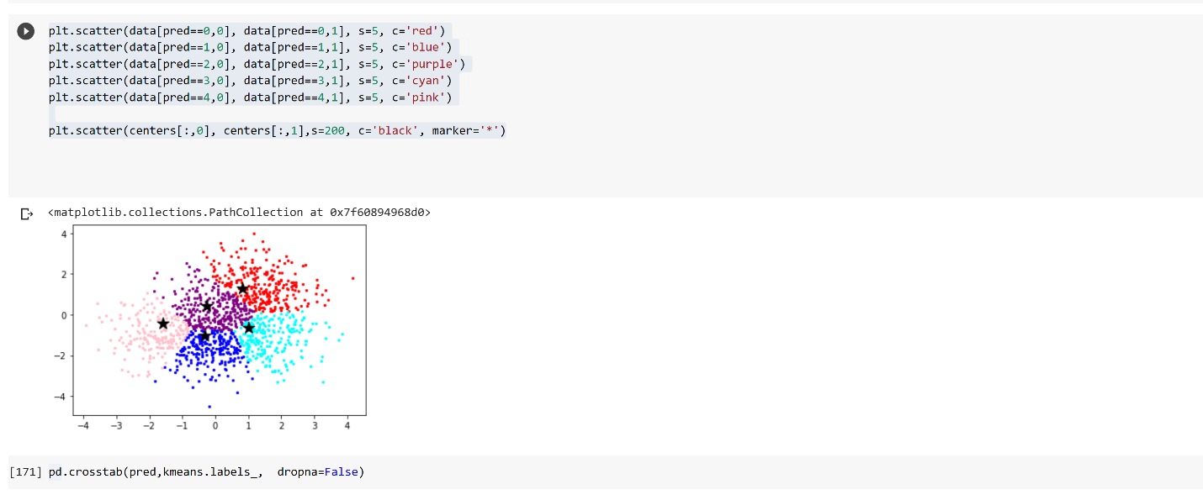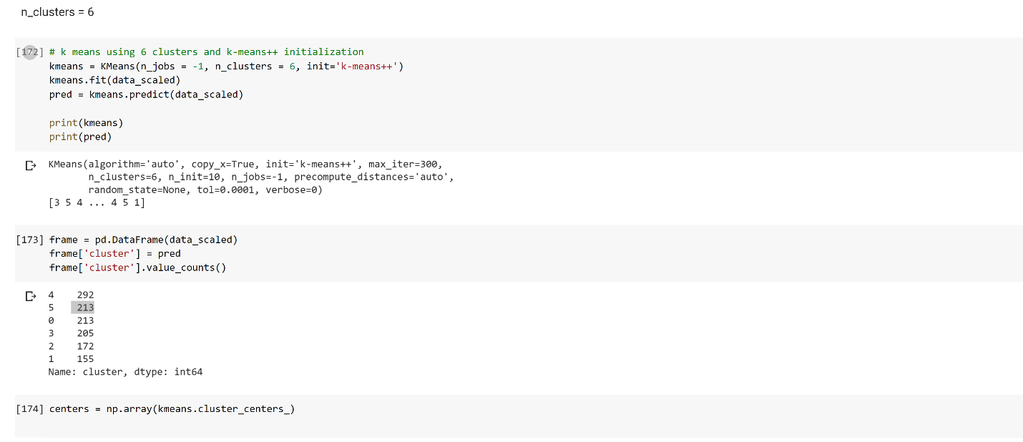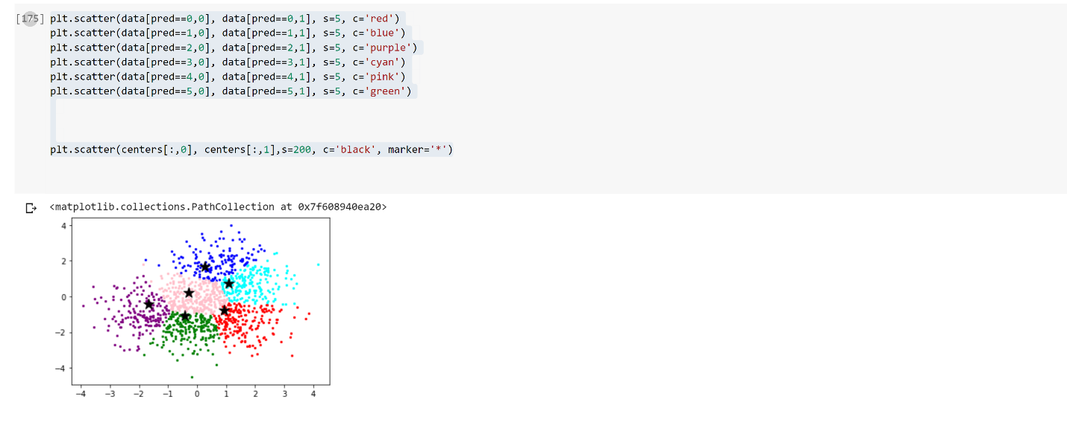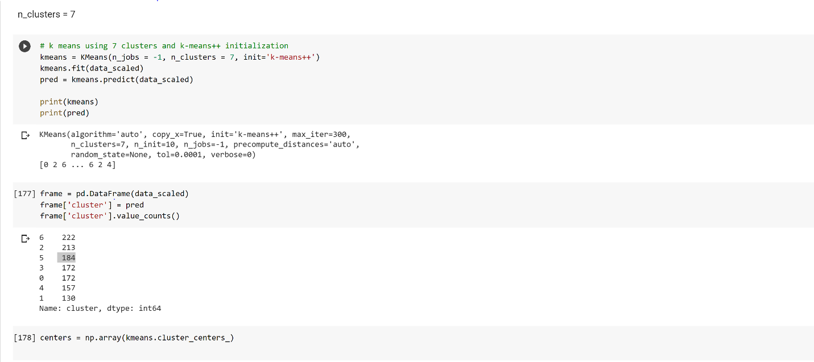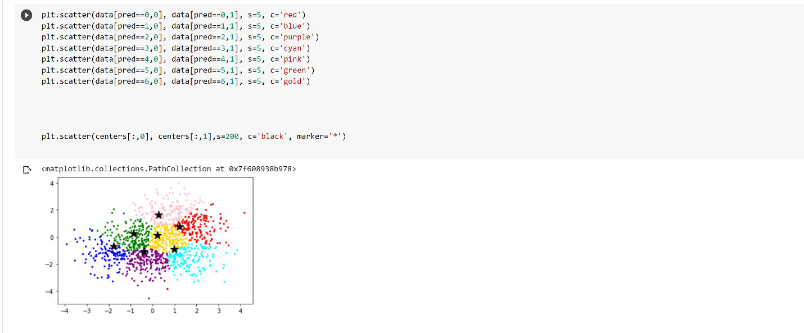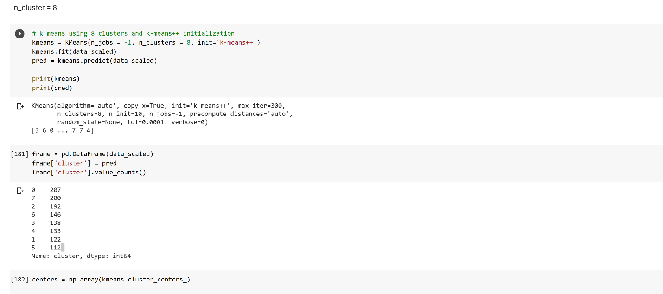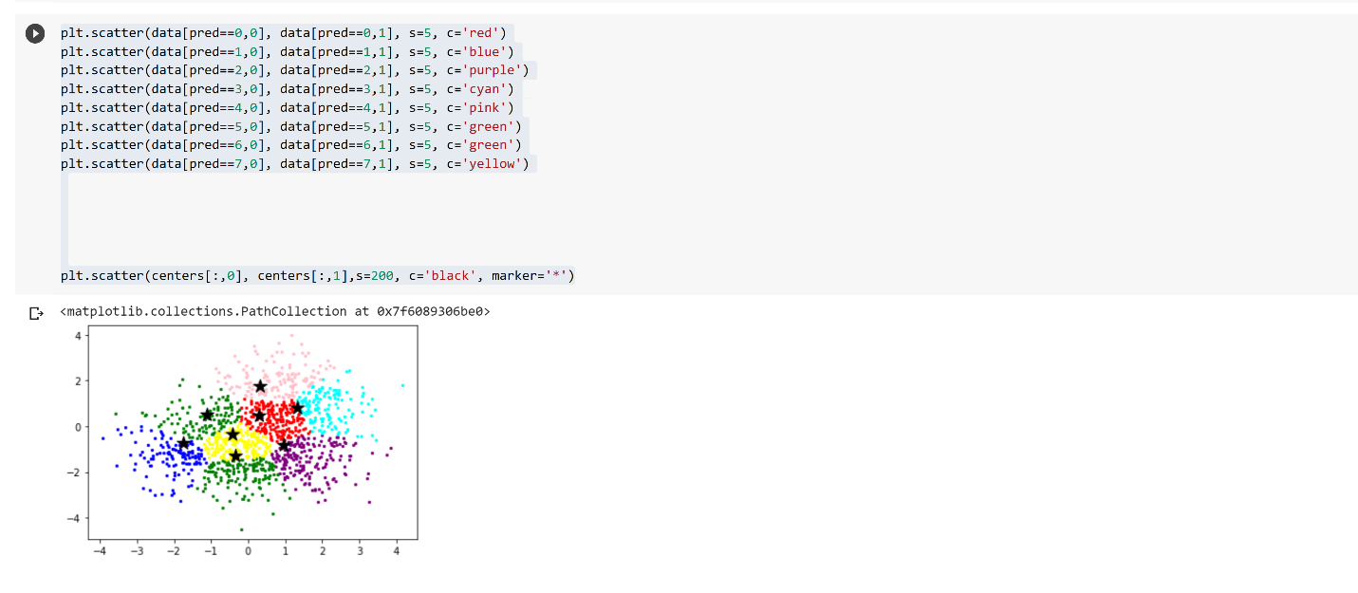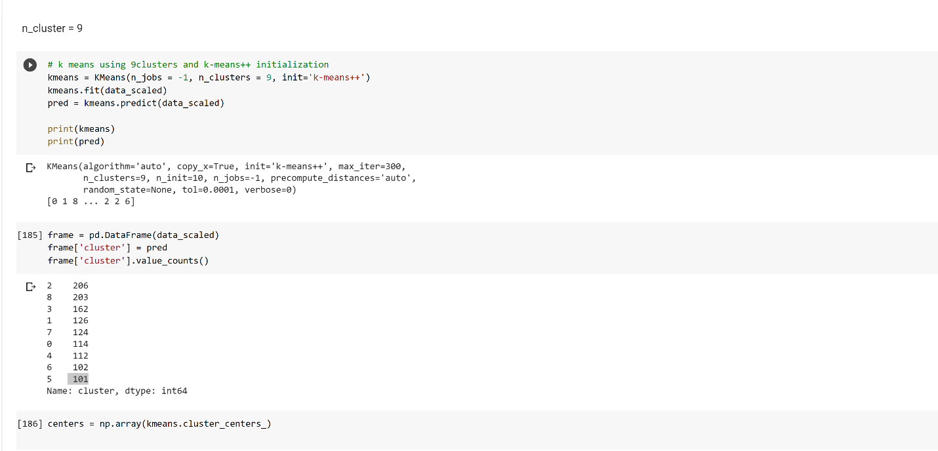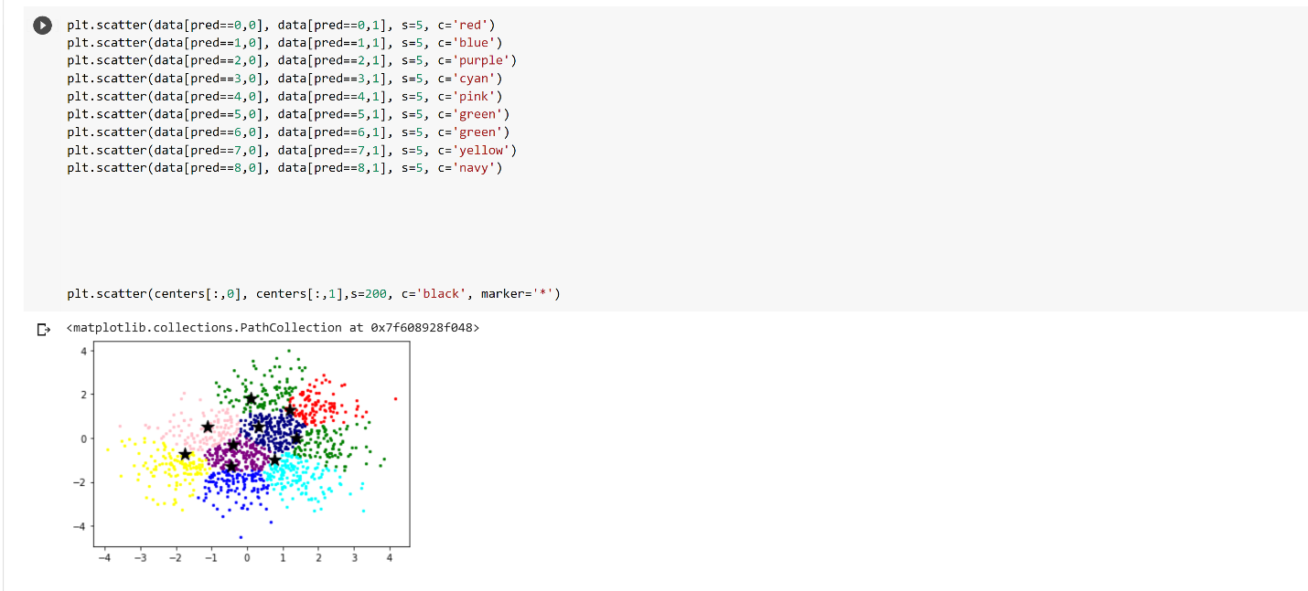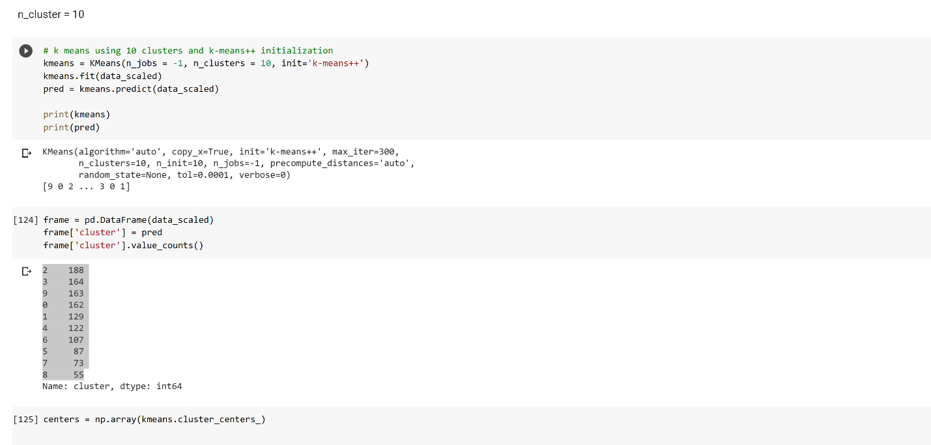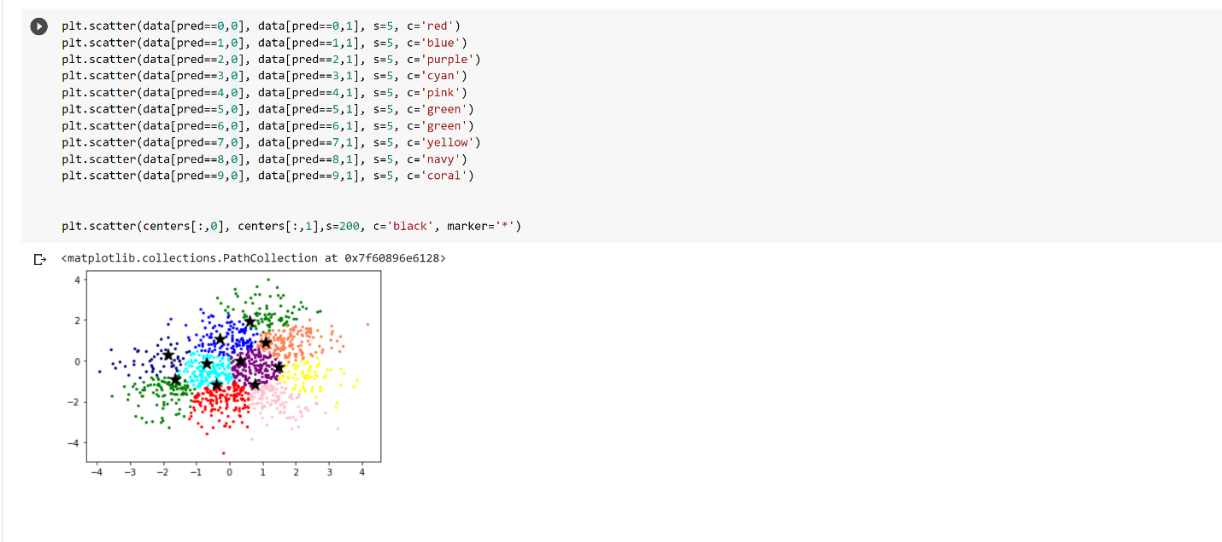

  - Output file link if applicable
https://github.com/UMKC-APL-BigDataAnalytics/icp7-irfancheemaa

  - Video link (YouTube or any other publicly available video platform)
https://umkc.hosted.panopto.com/Panopto/Pages/Viewer.aspx?id=4bdd4976-a970-4f23-8548-ac520164f0bc

  - Any inside about the data or the ICP in general
This was good introduction to K-Means and enjoyed working on the topic to gain better understanding. Would like to see more details on how the clusters are affected with changing the n_cluster value.

